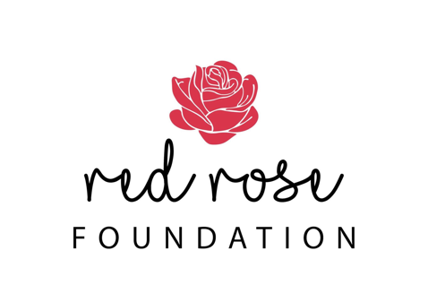

RED ROSE FOUNDATION TRAINING REQUEST FORM

Red Rose Foundation offers a number of live training sessions to enhance professional practice within the areas of community services, counselling, health, and justice as well as cross-sector opportunities to support the safety of women and children.

​

To make a request or enquiry regarding our training services, please contact us to discuss your training requirements including training budget.

Training is offered in a variety of formats and time frames.

|  |  |
| --- | --- |
| Date: |  |
| Organisation / agency: |  |
| Contact person: |  |
| Phone: |  |
| Email: |  |
| Training Needs: describe topic areas |  |
| Audience including number of participants |  |
| Geographic Location |  |
| Preferred dates |  |
| Desired training outcome |  |
| Are you able to provide training equipment. i.e smart tv, data projector, whiteboard  Please describe |  |
| Is this a catered event. Please describe |  |